**PRACTICAL- 1**

**AIM 1(a): Introduction to Computer Networking.**

**Computer Networking:** A computer network is a system of interconnected devices that can exchange data and share resources. It's not just a collection of computers; it includes various hardware components and software protocols that allow for seamless communication. The primary purpose of a network is to enable data exchange, resource sharing, and communication among devices.

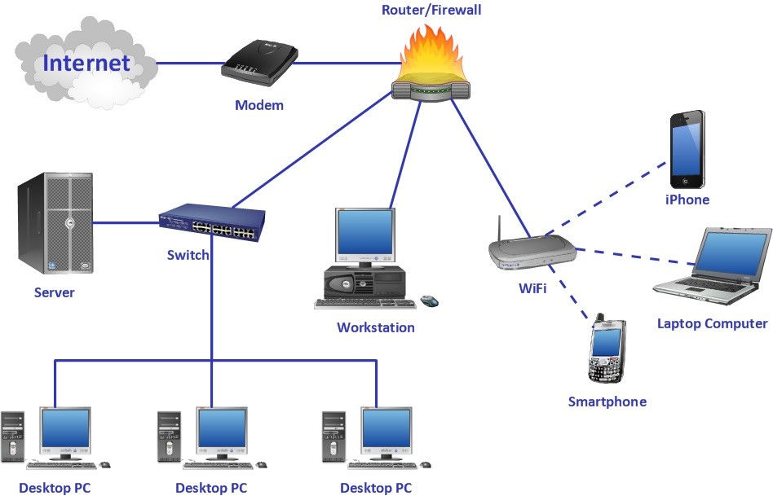

**Fig 1: Computer Network Structure**

**Types of Computer Networking:**

Computer Networks can be mainly divided into 3 different categories:

* **PAN (Personal Area Network)**
* **LAN (Local Area Network)**
* **MAN (Metropolitan Area Network)**
* **WAN (Wide Area Network)**

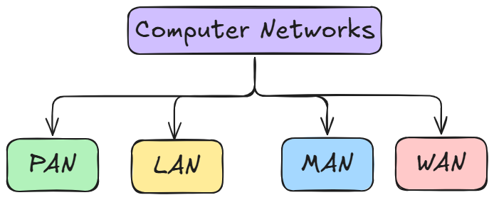

**Fig 2: Types of Networks**

1. **Personal Area Network:**

* PAN is the most basic type of computer network.
* It connects devices within a short range (1–10 meters), centered around one person or one device.
* Usually operates from one or two main devices.
* Connects only a few devices in a small local area.
* Allows communication and data sharing between personal devices such as smartphones, tablets, laptops, and wearables.
* **Example:** Using Bluetooth on a phone to share photos with nearby devices.
* **Advantages:**
* High transmission speeds
* Easy maintenance
* Very low costs

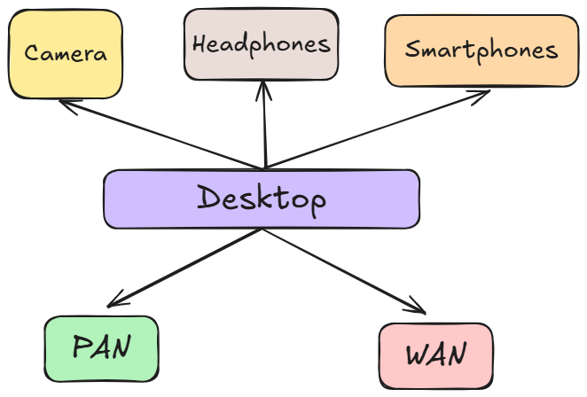

**Fig 3: Personal Area Network**

1. **Local Area Network:**

* A LAN is a network limited to a local area such as a home, office building, school, or campus.
* Any network within a single building or group of adjacent buildings is considered a LAN.
* It is the most frequently used network type.
* Connects a limited number of computers and devices due to its small geographical area.
* Specifically designed for shorter distances (up to ~2 km).
* LANs can be connected together to allow communication and data exchange.
* Used for sharing resources such as files, printers, and internet connections.
* Typically involves two or more computers connected via a server.
* Key technologies: Ethernet and Wi-Fi.
* **Advantages:**
  + Very High transmission speeds
  + Easy Maintenance
  + Low Cost

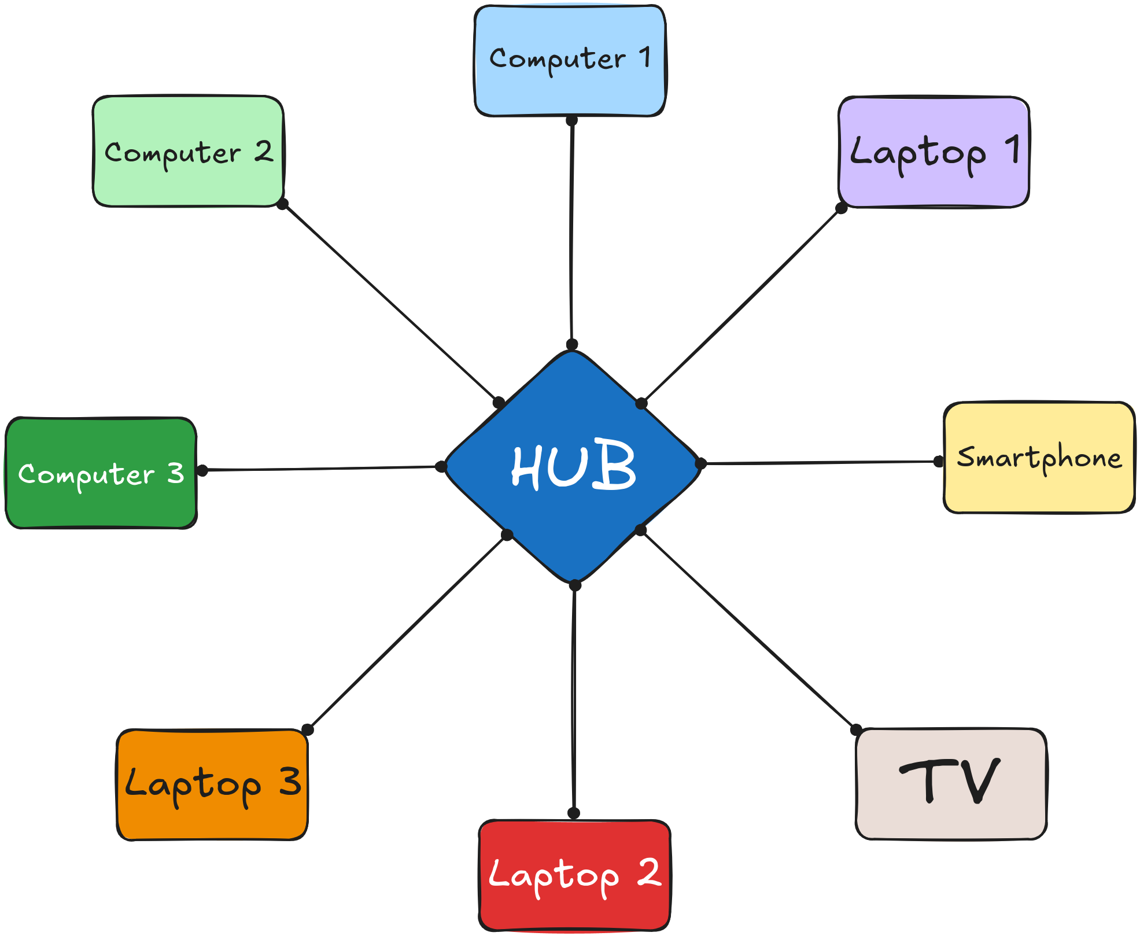

**Fig 4: Local Area Network**

1. **Metropolitan Area Network:**
   * A MAN covers a larger geographical area than a LAN but smaller than a WAN.
   * Typically spans a city or a large campus.
   * Connects multiple LANs together within a metropolitan region.
   * Used by organizations, government offices, universities, and ISPs to provide connectivity across a city.
   * Transmission medium: high-speed fiber optic cables or wireless connections.
   * Ranges from 5 km to 50 km approximately.
   * Provides moderate to high transmission speeds.
   * Example: A city-wide Wi-Fi network, or multiple branch offices of a company within the same city connected together.

* **Advantages:**
  + Wider coverage than LAN
  + High speeds compared to WAN
  + Supports efficient sharing of regional resources

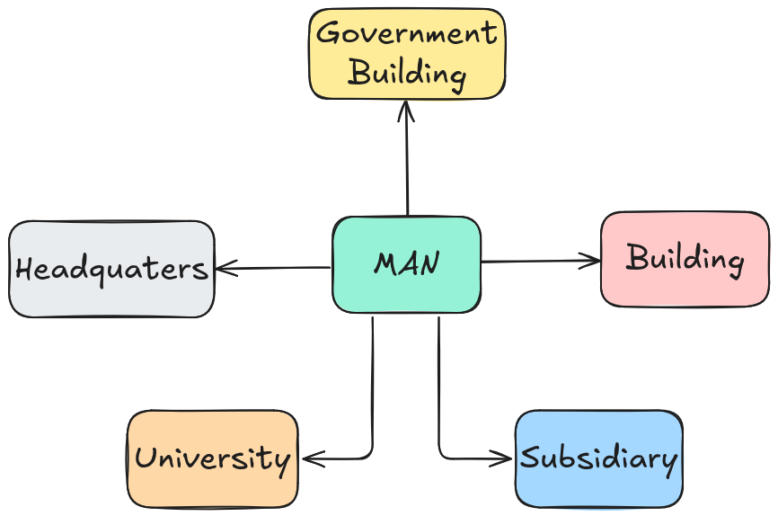

**Fig 5: Metropolitan Area Network**

1. **Wide Area Network:**
   * A WAN covers a very large geographical area (country, continent, or even worldwide).
   * Connects multiple LANs and MANs together.
   * The largest type of network, often used by multinational companies, governments, and telecom providers.
   * Internet is the best example of a WAN.
   * Transmission medium: satellite links, fiber optics, microwave, and undersea cables.
   * No distance limit; can span across thousands of kilometers.
   * Transmission speed is slower compared to LAN and MAN due to distance and traffic load.
   * More complex setup, requires routers and public communication links.

* **Advantages:**
  + Covers unlimited distance
  + Enables global communication
  + Connects remote offices and users worldwide

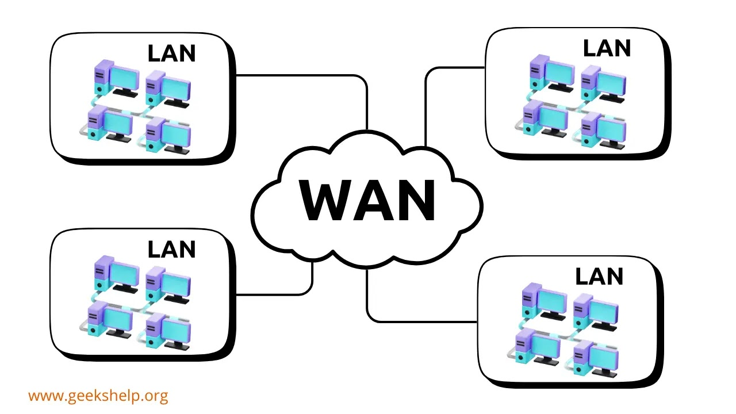

**Fig 6: Wide Area Network**

**AIM 1(b): Data Flow**

**Data Flow:** **Transmission mode**, also known as **communication mode** or **data flow**, is the way data is transferred between two devices through a communication channel such as optical fiber, copper wires, wireless channels, or storage media. It specifies the direction of information flow between devices and is sometimes called a directional mode. Data is transmitted as electromagnetic waves or digital signals, and the Physical Layer of the OSI model ensures that this transfer occurs correctly.

**Transmission modes are mainly of three types:**

* **Simplex**
* **Half-duplex**
* **Full-duplex**

1. **Simplex:**
   * In this mode, communication goes only in **one direction**.
   * The sender can transmit information, but the receiver has no way to reply back.
   * It’s mainly used where feedback isn’t necessary, so the process stays simple.
   * **Examples:** Keyboards, radio, etc.

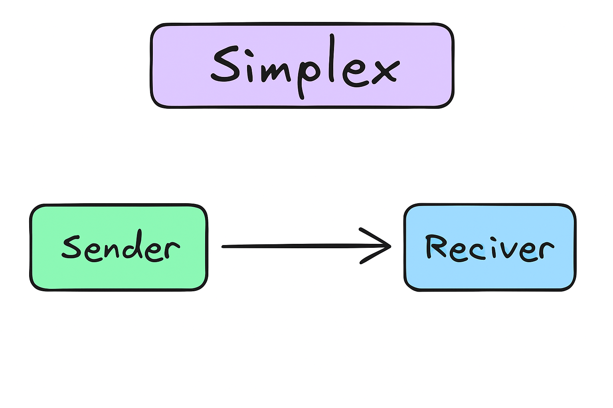

**Fig 7: Simplex Data Flow**

1. **Half-Duplex:**
   * Here, communication works in **both directions**, but **not at the same time**.
   * When **one device is sending**, the **other must wait** and only then reply.
   * This back-and-forth style makes it slower than full duplex, but still useful where two-way communication is needed.
   * **Example:** Walkie-talkies, etc

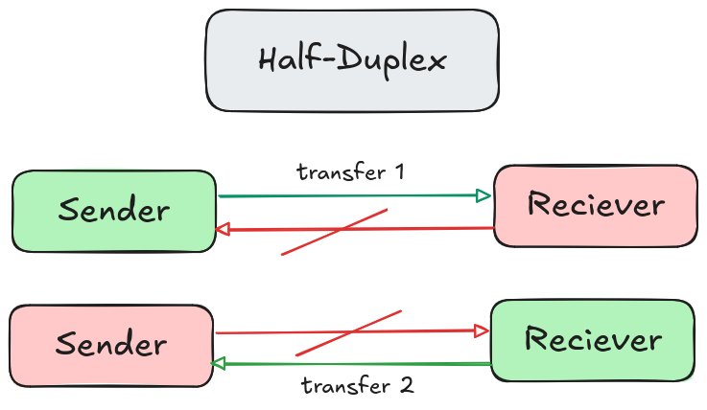

**Fig 8: Half-Duplex Data Flow**

1. **Full-Duplex:**
   * In this mode, communication happens in **both directions at the same time**.
   * Both devices can **send and receive data simultaneously**, which makes it the fastest and most efficient method.
   * It’s widely used in real-time communication where delays can’t be afforded.
   * Example: Telephone calls, video calls, etc.

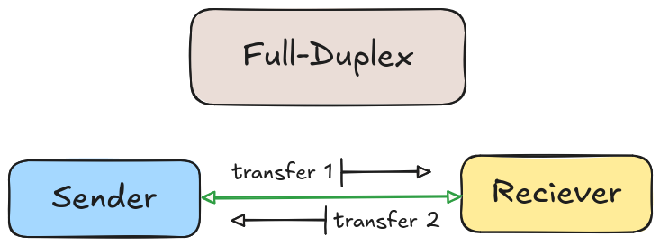

**Fig 9: Full-Duplex Data Flow**

**Applications of Computer Networking:**

1. **Business Applications:**
   * Enables smooth communication between employees and departments through emails, video calls, and messaging platforms.
   * Allows sharing of resources such as printers, servers, and software across the organization.
   * Supports remote access so employees can work securely from home or while traveling.
   * **Examples:** Microsoft Teams, Slack, etc.
2. **Educational Applications:**
   * Provides access to online study materials, e-books, and recorded lectures.
   * Supports virtual classrooms and online exams through e-learning platforms.
   * Encourages collaboration between students and teachers via forums, video calls, and group projects.
   * **Examples:** Google Classroom, Moodle, etc.
3. **Healthcare Applications:**
   * Stores and shares patient records digitally, reducing paperwork and errors.
   * Enables telemedicine, allowing patients to consult doctors online.
   * Supports collaboration between hospitals by sharing diagnostic data and research findings.
   * **Example:** Hospitals using digital health records, teleconsultation services, etc
4. **Entertainment Applications:**
   * Provides access to online games, music, and video streaming platforms.
   * Allows real-time multiplayer gaming and live streaming without interruptions.
   * Makes content globally available for creators and audiences.
   * **Example:** Watching movies and shows on Netflix, playing games on Steam, etc.
5. **Military Applications:**
   * Uses private, secure networks for defense communication and coordination.
   * Helps in intelligence sharing, satellite-based navigation, and surveillance.
   * Ensures safety of classified information during military operations.
   * **Example:** The U.S. Defense Information Systems Network (DISN) used for secure military communications, etc.
6. **Scientific Applications:**
   * Facilitates collaboration between researchers across the globe.
   * Supports data sharing, simulations, and joint experiments.
   * Provides access to supercomputers and large research databases.
   * **Example:** CERN (European Organization for Nuclear Research) uses networks to share particle physics data worldwide, etc.
7. **Transportation Applications:**
   * Used to monitor and control traffic signals and reduce congestion.
   * Helps track vehicles through GPS and optimize routes.
   * Manages airline reservations, train schedules, and logistics systems.
   * **Examples:** Uber, Rapido, Ola, etc.